**DAILY ASSESSMENT**

|  |  |  |  |
| --- | --- | --- | --- |
| **Date:** | **13/06/2020** | **Name:** | **Davis S. Patel** |
| **Course:** | **VLSI** | **USN:** | **4AL16EC045** |
| **Topic:** | **Digital VLSI Design Virtual lab** | **Semester & Section:** | **8th - A** |
| **GitHub Repository:** | **Davis** |  |  |

|  |
| --- |
| **FORENOON SESSION DETAILS** |
| **Image of session** |

**REPORT –**

The metal–oxide–semiconductor field-effect transistor (MOSFET) is a transistor used for amplifying or switching electronic signals. In MOSFETs, a voltage on the oxide-insulated gate electrode can induce a conducting channel between the two other contacts called source and drain. The channel can be of n-type or p-type, and is accordingly called an nMOSFET or a pMOSFET. Figure 1 shows the schematic diagram of the structure of an nMOS device before and after channel formation.

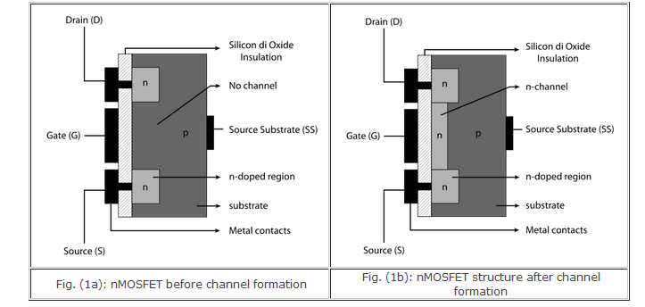

The inverter is universally accepted as the most basic logic gate doing a Boolean operation on a single input variable. Fig.1 depicts the symbol, truth table and a general structure of a CMOS inverter. As shown, the simple structure consists of a combination of an pMOS transistor at the top and a nMOS transistor at the bottom.

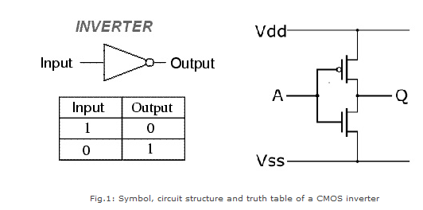

CMOS is also sometimes referred to as complementary-symmetry metal–oxide–semiconductor. The words "complementary-symmetry" refer to the fact that the typical digital design style with CMOS uses complementary and symmetrical pairs of p-type and n-type metal oxide semiconductor field effect transistors (MOSFETs) for logic functions. Two important characteristics of CMOS devices are high noise immunity and low static power consumption. Significant power is only drawn while the transistors in the CMOS device are switching between on and off states. Consequently, CMOS devices do not produce as much waste heat as other forms of logic, for example transistor-transistor logic (TTL) or NMOS logic, which uses all n-channel devices without p-channel devices.

A ring oscillator is a device composed of an odd number of NOT gates whose output oscillates between two voltage levels, representing true and false. A schematic diagram of a simple three inverter ring oscillator is shown in Fig.1.

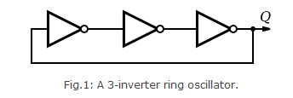

The NOT gates, or inverters, are attached in a chain; the output of the last inverter is fed back into the first. Because a single inverter computes the logical NOT of its input, it can be shown that the last output of a chain of an odd number of inverters is the logical NOT of the first input. This final output is asserted a finite amount of time after the first input is asserted; the feedback of this last output to the input causes oscillation. A real ring oscillator only requires power to operate; above a certain threshold voltage, oscillations begin spontaneously. To increase the frequency of oscillation, two methods may be used. Firstly, the applied voltage may be increased; this increases both the frequency of the oscillation and the power consumed, which is dissipated as heat.

**Static logic** is a design methodology in integrated circuit design where there is at all times some mechanism to drive the output either high or low. For example, in many of the popular logic families, such as TTL and traditional CMOS, there is always a low-impedance path between the output and either the supply voltage or the ground. The most widely used logic style is static CMOS.

A static CMOS gate is a combination of two networks, called the pull-up network (PUN) and the pull-down network (PDN). The function of the PUN is to provide a connection between the output and VDD anytime the output of the logic gate is meant to be 1 (based on the inputs). Similarly, the function of the PDN is to connect the output to VSS when the output of the logic gate is meant to be 0 (based on the inputs). The PUN and PDN networks are constructed in a mutually exclusive fashion such that, one and only one of these networks is conducting in the steady state.

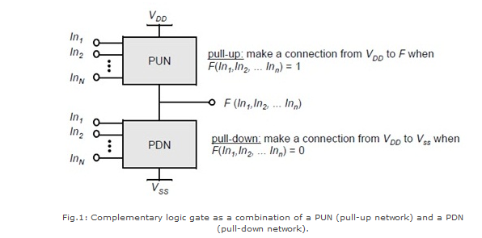

**Dynamic logic** is a design methodology in integrated circuit design in that it uses a clock signal in its implementation of combinational logic circuits. In dynamic logic, there is not always a mechanism driving the output high or low. In the most common version of this concept, the output is driven high or low during distinct parts of the clock cycle. Dynamic logic requires a minimum clock rate fast enough that the output state of each dynamic gate is used before it leaks out of the capacitance holding that state. The basic construction of a dynamic logic gate is shown in fig.2. The PDN (pull-down network) is constructed exactly as in complementary CMOS. The operation of this circuit is divided into two major phases: precharge and evaluation, with the mode of operation determined by the clock signal CLK.

A multiplexer or mux is a combinational circuits that selects several analog or digital input signals and forwards the selected input into a single output line. A multiplexer of 2n inputs has n selected lines, are used to select which input line to send to the output.

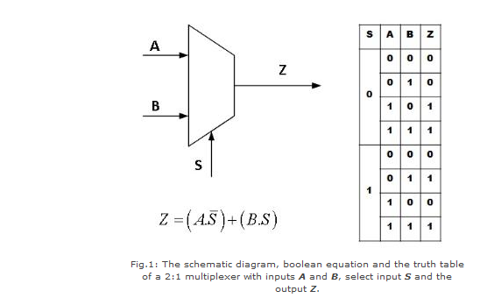

Figure 2 shows how a 4:1 MUX can be constructed out of two 2:1 MUXs.

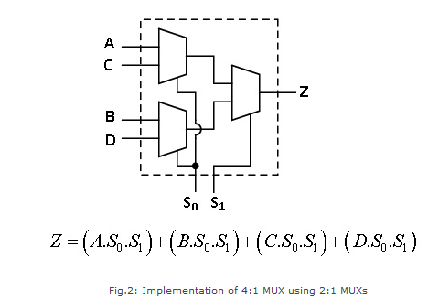

**DAILY ASSESSMENT**

|  |  |  |  |
| --- | --- | --- | --- |
| **Date:** | **13/06/2020** | **Name:** | **Davis S. Patel** |
| **Course:** | **MySQL** | **USN:** | **4AL16EC045** |
| **Topic:** | **Real Life PHP Introduction**  **About The Author** | **Semester & Section:** | **8th - A** |
| **GitHub Repository:** | **Davis** |  |  |

|  |
| --- |
| **AFTERNOON SESSION DETAILS**  **Image of Session** |

**REPORT –**

**PHP** started out as a small open source project that evolved as more and more people found out how useful it was. Rasmus Lerdorf unleashed the first version of PHP way back in 1994.

* PHP is a recursive acronym for "PHP: Hypertext Preprocessor".
* PHP is a server side scripting language that is embedded in HTML. It is used to manage dynamic content, databases, session tracking, even build entire e-commerce sites.
* It is integrated with a number of popular databases, including MySQL, PostgreSQL, Oracle, Sybase, Informix, and Microsoft SQL Server.
* PHP is pleasingly zippy in its execution, especially when compiled as an Apache module on the Unix side. The MySQL server, once started, executes even very complex queries with huge result sets in record-setting time.
* PHP supports a large number of major protocols such as POP3, IMAP, and LDAP. PHP4 added support for Java and distributed object architectures (COM and CORBA), making n-tier development a possibility for the first time.
* PHP is forgiving: PHP language tries to be as forgiving as possible.
* PHP Syntax is C-Like.

**Common uses of PHP**

* PHP performs system functions, i.e. from files on a system it can create, open, read, write, and close them.
* PHP can handle forms, i.e. gather data from files, save data to a file, through email you can send data, return data to the user.
* You add, delete, modify elements within your database through PHP.
* Access cookies variables and set cookies.
* Using PHP, you can restrict users to access some pages of your website.
* It can encrypt data.

**Characteristics of PHP**

Five important characteristics make PHP's practical nature possible −

* Simplicity
* Efficiency
* Security
* Flexibility
* Familiarity

PHP is a server-side scripting language, mainly used for web development but also used as a general-purpose programming language. Object-Oriented Programming (PHP OOP), is a type of programming language principle added to php5 that helps in building complex, reusable web applications.

The Object Oriented concepts in PHP are:

* Class − This is a programmer-defined data type, which includes local functions as well as local data. You can think of a class as a template for making many instances of the same kind (or class) of object.
* Object − An individual instance of the data structure defined by a class. You define a class once and then make many objects that belong to it. Objects are also known as instance.
* Inheritance − When a class is defined by inheriting existing function of a parent class then it is called inheritance. Here child class will inherit all or few member functions and variables of a parent class.
* Polymorphism − This is an object oriented concept where same function can be used for different purposes. For example function name will remain same but it make take different number of arguments and can do different task.
* Overloading − a type of polymorphism in which some or all of operators have different implementations depending on the types of their arguments. Similarly functions can also be overloaded with different implementation.
* Data Abstraction − Any representation of data in which the implementation details are hidden (abstracted). * Encapsulation − refers to a concept where we encapsulate all the data and member functions together to form an object.
* Constructor − refers to a special type of function which will be called automatically whenever there is an object formation from a class.
* Destructor − refers to a special type of function which will be called automatically whenever an object is deleted or goes out of scope.

Picking up the right **CMS** is the most vital decision when you are starting a web development process. Because it lets you to plan your app requirements and its solutions in advance. In the way, you get the idea about your proposed app design, features and performance. Therefore, opting the best PHP CMS is the most important part of your app development cycle. And hence requires appropriate knowledge to choose the best one.

While today we have many open source CMS available in the market. The choice depends upon our app requirements. Whether you want to build a simple dynamic website or a fully functional ecommerce store. There are multiple types of CMSs available in the market which could lessen your workload. As not every developer wants to write orthodox HTML and CSS to build web pages.

Joomla is an open source [content management system](https://en.wikipedia.org/wiki/Content_management_system) (CMS). It helps you build powerful dynamic websites and applications. It has an intuitive interface that helps you use its features and functionality to the fullest.

Joomla has gained huge popularity over the last decade and successfully grown into one of the most widely used content management systems globally. Since its inception in 2005, it has successfully captured the massive following and it certainly has over 99 + million downloads till date.

Joomla is written in [PHP](https://blog.templatetoaster.com/php-7-tutorial-features/) and use MySQL database to store the data while using object-oriented programming techniques. It can be set up with one-click install through web hosting control panel. There are hundreds of articles exist on the web to help you with [how to install Joomla](https://blog.templatetoaster.com/how-to-install-joomla/).

Joomla uses [Model-View-Controller](https://en.wikipedia.org/wiki/Model%E2%80%93view%E2%80%93controller) (MVC) design architecture. According to the MVC pattern when Joomla process a request, it first analyzes the URL to evaluate which component will process the request. The model contains the data used by the component. It is also the Model’s responsibility to update the database when and where required. The view is accountable for producing the output. It can contact with the model to get the needed information. After the view has produced the output, the component gives back the control to the Joomla framework which then executes the template